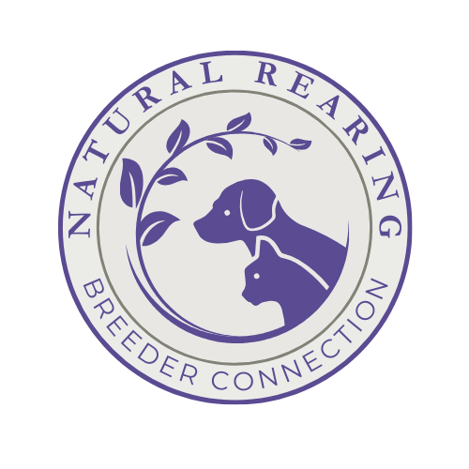
APPLICATION FOR MEMBERSHIP
Natural Rearing Breeder Connection

Name: Date:

Address: City:

State/Province: Zip/Postal Code:

E-Mail Address: Phone:

Cattery Name:

Website Address:

Social Media Handles and any alternate SM names:

Please send a FB friend request to Krystal Beers.

Number of years you have been feeding raw:

Number of years not vaccinating:

Breeds You Own (list number of cats & breeds):

Why do you want to join the NRBC?

What registries do you use for your breeding cats?

What registry do you register litters with?

Membership in breed clubs (Please list):

What cleaning, laundry, and grooming products do you use?

In what objective venue(s) do you test your breeding program?

What health tests have you performed on your breeding cats? (Please email proof of tests)

Have you performed genetic (DNA) testing on your breeding cats? If so, which lab? (Pease email proof)

Do you use a socialization/enrichment program with your litters? Yes ____ No ____

If “no”, do you do ENS or any other socialization or training with your kittens – please explain:

Do you educate your kitten buyers on the benefits of raw feeding and not vaccinating or using toxic chemicals? Yes _____ No _____

Do you have a litter due or a current litter where all the kittens are not reserved yet?
Yes ____No ____

If yes, would you like to purchase a litter listing on the website?
Yes ____No ____

Please list two references that we may contact:

If you have any of the following skills, would you be interested in one of the following volunteer positions within the NRBC?

___Graphics
___Advertising
___Brochure Preparation
___Newsletter or Publishing
___Photography
___Printing
___Scientific Research
___Education
___Writing
___Newsletter Columnist
___Publicity
___Other

As signified by my signature herein, I certify that the above information is true and correct. Also, if approved for membership, I agree to abide by the Code of Ethics of the Natural Rearing Breeder Connection.

APPLICANT SIGNATURE:

Thank you for taking the time to apply for membership!

Please Email photo of a hand-signed or e-signed copy to nrbreeder@outlook.com; or mail the signed hard copy to:

Krystal Beers
- NRBC
19 Heritage Ln
Republic, WA 99166

