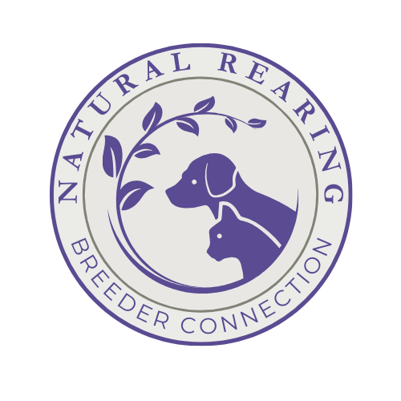
Referral Network Application
Natural Rearing Breeder Connection

For natural dog trainers, groomers, daycare, and natural health care practitioners.

Name_______________________________________________________________ Date____________

City________________________ State/Province _______________________________

Business Phone________________________

Business name:

What services do you offer?

If a physical business, do you use only non-toxic cleaners and grooming products?

If a groomer/trainer/daycare provider, what is your vaccination policy?

For animal health care practitioners, what formal education/training do you have?

How many years have you been consulting?
How many hours of continuing education do you accumulate each year?

Do you agree to give a reciprocal web link to NRBC?

Website Address of Business:

E-Mail Address of Business:

Business Facebook:

Specific information that you would like included in your listing:

*Email a photo or logo for the listing.*

Provide two references we may contact:

Please submit application for approval to nrbreeder@outlook.com

